EENG 5560 HW 4

Name: *Hari krishna Gonemadatala*

Table of Contents

State Diagram: 3

Explanation 4

State Table: 5

Generated RTL Block Diagram\Schematic 5

Results 6

Waveforms 6

Calculation: 6

# State Diagram:

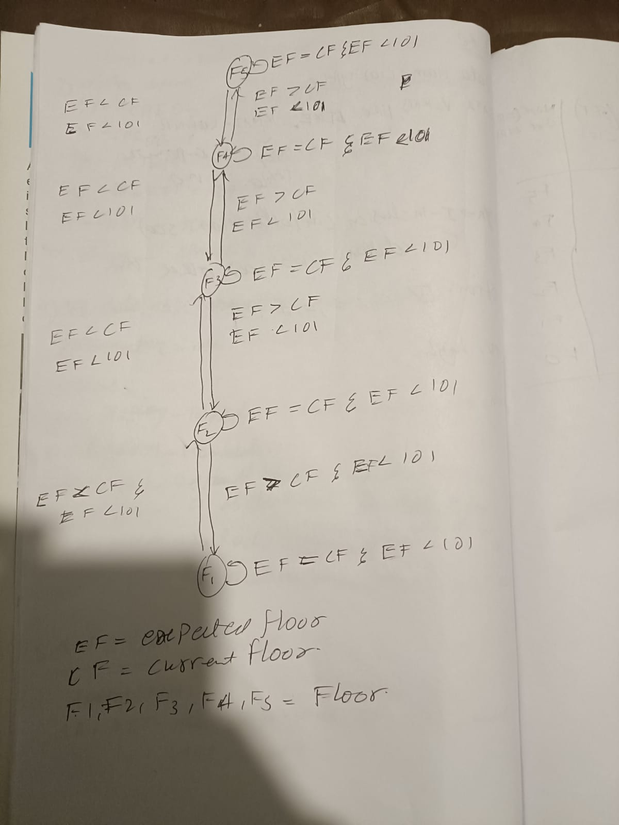

* **Overall Component:**
* **Overall ports:**
  + **Inputs:**
* Expected_Floor( 2 downto 0)
* **Signal:**

Clock (1 bit)

* + **Outputs:**
* Up, Down, Destination_floor ( 2 downto 0)
* **Necessary intermediate signals:**
  + Current_Floor, Next_Floor.

# Explanation

* Expected floor is the input the value should between “000” to “100” then the lift moves. If you give the value other than above values lift will now moves.

|  |  |
| --- | --- |
| Input | Floor |
| 000 | Floor 1 |
| 001 | Floor 2 |
| 010 | Floor 3 |
| 011 | Floor 4 |
| 100 | Floor 5 |

# State Table:

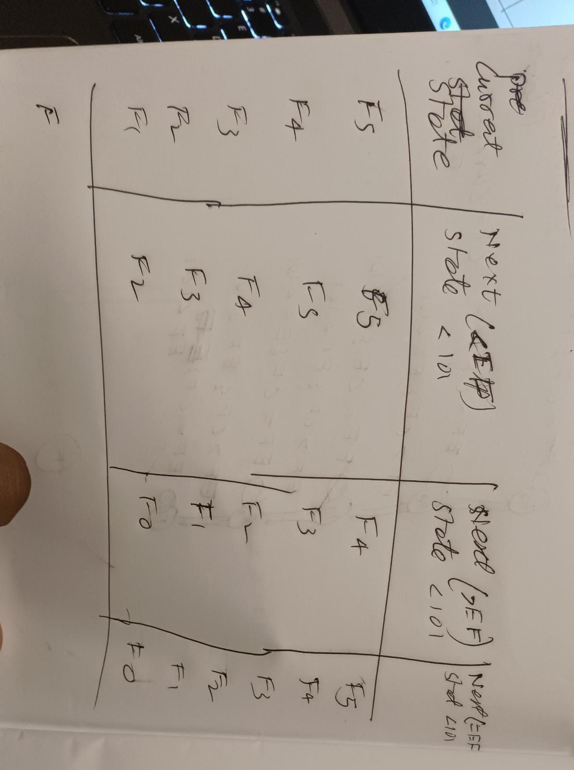

# Generated RTL Block Diagram\Schematic

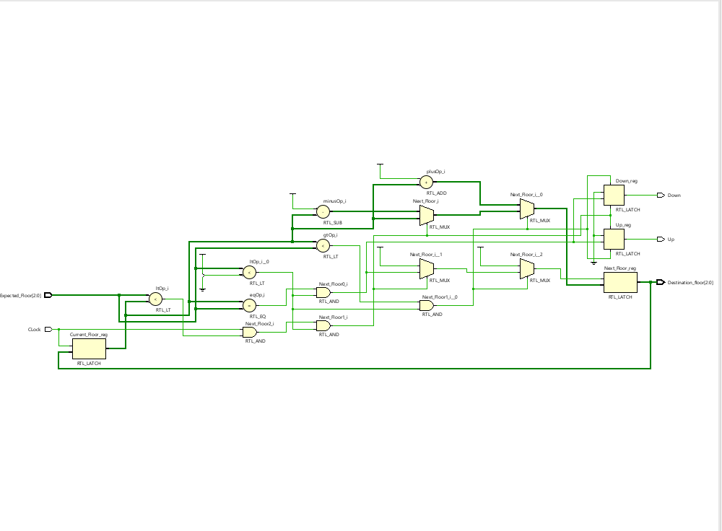

Figure 5 - generated RTL schematic.

# Results

## Waveforms

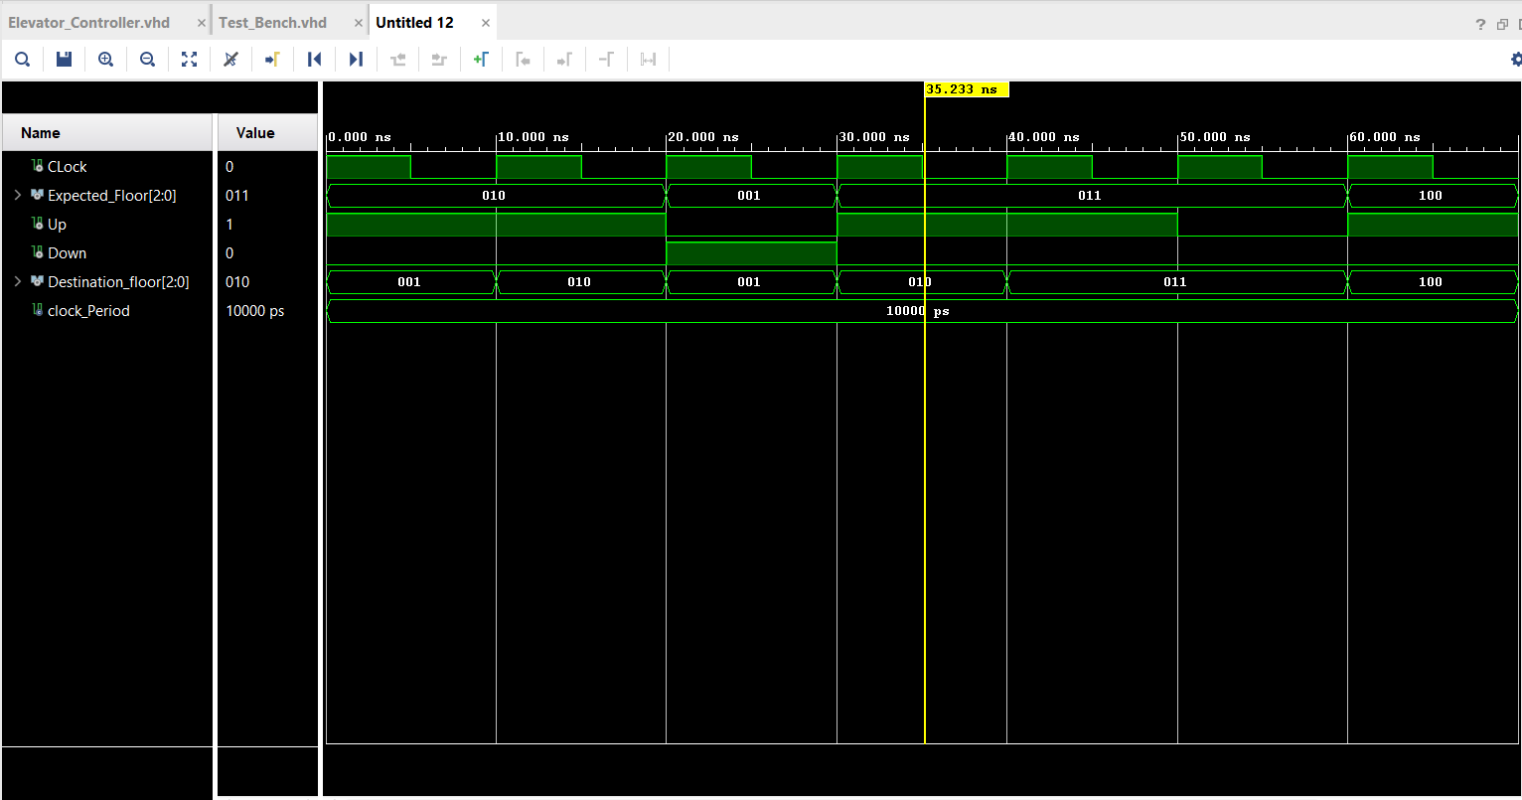

Figure 6 - Waveforms

# Calculation:

**Test case 1**

**Input:** 010( floor3)

**Current floor:** 000(Floor 1)

**Next floor:** 001(Floor2)

**Lift :** Moves up

**Output:** 010 ( floor3)

**Test case 2**

**Input:** 001( floor2)

**Current floor:** 010(Floor 1)

**Next floor:** 001(Floor2)

**Lift :** Moves down

**Output:** 001 ( floor2)